Toto goes to the beach

Jojo Toto¹, Jiji Titi¹ & Juju Tutu²
¹DMMM, Politecnico di Bari, Bari, Italia
²Laboratory of Fluid Dynamics, ENSAM, Paris, France

Here goes the text of your abstract with a strict limit of one page.

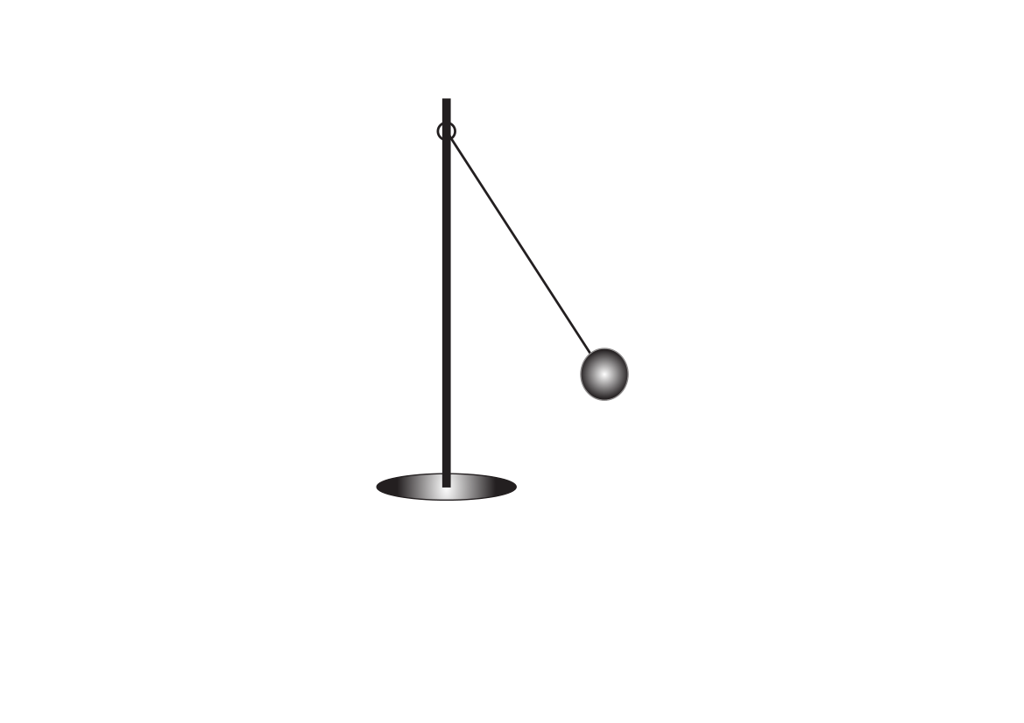
Figure 1. Sketch of the experimental setup.

BLU

References

[1] P. Toto, S. Titi, and J.-C. Tata. Numerical study of something. Journal of everything 15: 43–62, 2017.

